Special-shaped Card Precision Engraving and Cutting Machine YLP-PE

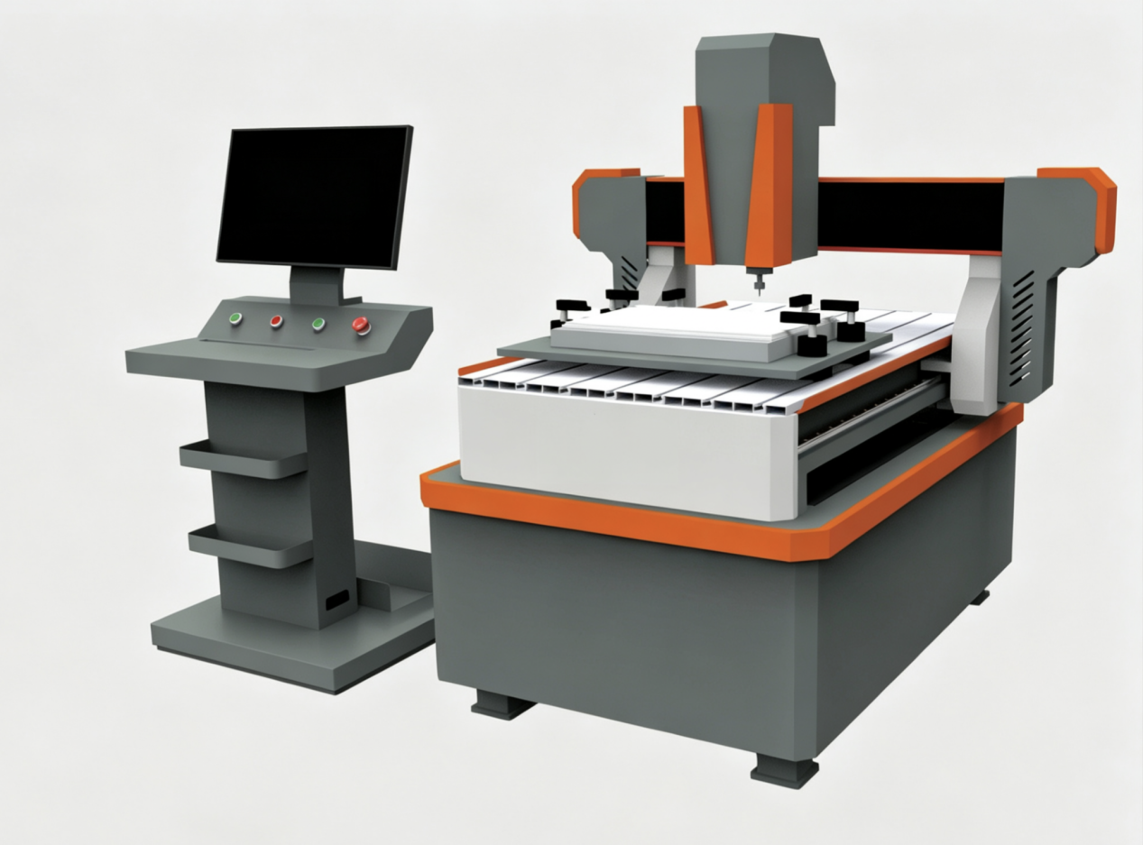
Special-shaped Card Precision Engraving and Cutting Machine YLP-PE is also known as special-shaped card visual positioning precision carving machine or irregular card die cutting machine, which can provide a mold-free cutting production solution for non-standard and irregular cards. This machine does not require any up-down punching molds and it can produce and cut irregular cards of any shape in a speedy and precise way. It is a necessary equipment for various card manufacturing factories and advertising graphic and text fast printing processing centers. In addition to the card cutting function, this machine can also achieve precise hole cutting function.

Special-shaped card precision engraving and cutting machine YLP-PE has been widely used in many industries including card making industry as well as advertising graphic and text fast printing processing center for the speedy order processing of various cards, identification signs and special-shaped card production.

Key Advantages:
- The machine uses a high-precision industrial positioning camera and an automatic visual edge inspection system, which can achieve automatic recognition and positioning, ensuring high precision in card cutting.
- The machine cutting system is equipped with a high-speed engraving spindle with a speed of 36000 revolutions per minute, ensuring smooth and even cutting of various irregular card edges.
3. The machine uses automatic rotating fixtures, which can usually hold 5-6 pieces of material at once, ensuring higher level of production efficiency.
4. Automatic oil injection, equipped with random air guns, reducing manual maintenance and cleaning costs.

Technical Parameters：
- Working Speed：8-9 meters per minute.
- Spindle rotation speed: 36000 RPM.
- Maximum processing stroke: 600*600mm
- Machine size: 1200*1370*1450mm.

